Name:

Screenshot showing added columns

Activity 1: Looking at the screenshot below, complete column D showing the VAT rate of 17.5%

Activity 2: In column E calculate the Price including the VAT

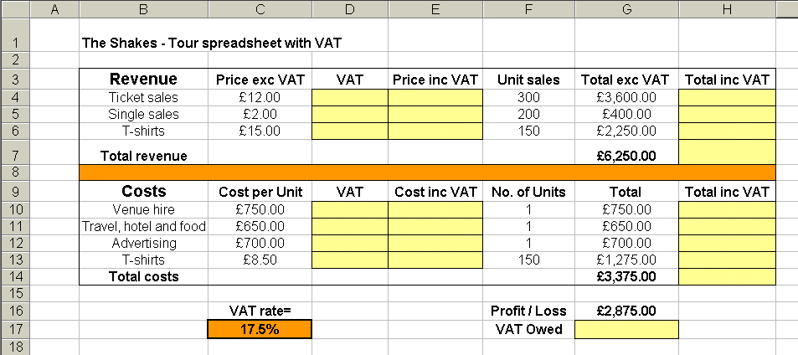
Activity 3: In column H calculate the Total including the VAT

